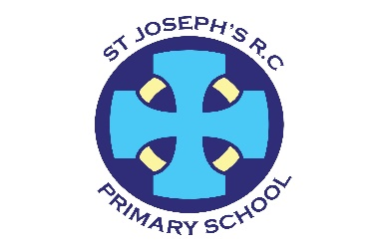
St. Joseph’s R.C. Primary School
Fairoak Avenue
Newport
NP19 8FW
01633 258801
Stjosephsrc.primary@newportschools.wales
Headteacher: Mrs Tara Lynch
Monday 9th October 2023

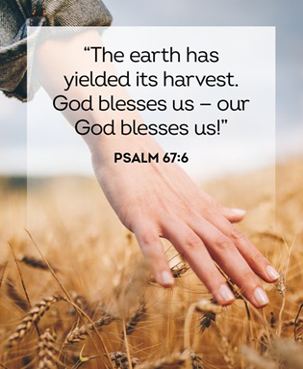
27th Sunday of the Year (A) – Matthew 21:28-30

Harvest Assembly
On 11th October, Year 4 (St Veronica) will lead us in a Harvest Assembly. We celebrate and give thanks to God for our food and the crops, which have been safely harvested. Year 4 parents are also invited to see their children in this assembly. From Monday 2nd October we asked that the children bring in a donation of a tin, dried food such as pasta/rice and any long-life products. The week beginning 9th October children can donate fruit and vegetables.
We will donate these items to a nearby food bank and the SVP. They are also grateful for items such as toothpaste, toothbrushes, nappies, wipes and personal hygiene products.

Open day sessions
We are running 3 sessions for parents who wish to apply for Reception places for September 2024. There will be a school tour and a chance to ask questions and have a chat with the staff. Please phone the school office to register for a session.
Monday 23rd Oct – 9.30-.10.30 or 11-12
Wednesday 25th Oct – 2-3pm

Sustrans - School street closure
Thank you for supporting the school street closure last week, it made Fairoak Avenue a safer place for our children to travel to school. Thank you also to the children from our school Heddlu Bach who wore their uniforms proudly and helped the Sustrans representatives. Here is a link so you can have your say. http://bit.ly/NewportSchoolStreets

Football
Our school team played a match against St David’s Primary School on Tuesday and the score was 2-2. Miss Beckett said they played really well. Well done team!

Grandparents Day 2023
What a lovely day! Thank you for supporting such a special day. Both the children and grandparents loved it!


Shwmae Day
On Friday 13th October we will celebrate our Welsh culture and language. The children can wear red, white and green clothing to school on this day and we will be using and practising our Welsh language skills.

Buddy assembly
Thank you to Year 6 (St Teresa) and Reception (St Peter) for their Buddy Assembly last Friday – our oldest pupils did an amazing job of introducing our youngest pupils to everyone. Thank you to all the families who came to watch, it was lovely to see you.

Calendar Dates
Thurs 14th Sept – 23rd Oct | County in the Community Year 4 (St Veronica)
Weds 20th Sept – 25th Oct | Gateway Rugby – Y3 St Cecilia  (Every 2 weeks)
Mon 9th Oct | Year 1 (St Dwynwen) Community walk
Weds 11th Oct | Y4 (St Veronica) Harvest Service- 2.30pm parents invited
Fri 13th Oct | Shwmae Day – wear red, white or green
Wed 18th Oct | Y6 (St Teresa) visit to Raglan Barracks
Thurs 19th Oct | Show Racism the Red Card – Wear Red
Fri 20th Oct | Training Day – school closed to pupils
Mon 23rd Oct | Open morning 9.30-11.30
Tues 24th Oct | Y3 (St Cecilia) – All Saints assembly 2.45pm parents invited
Thurs 26th Oct | County in the Community after school club cancelled
Fri 27th Oct | Flu Immunisation – Whole School
Mon 30th Oct – Fri 3rd Nov | HALF TERM – SCHOOL CLOSED
Tues 7th Nov | Big Me Day – dress up as your future profession. Details to follow.
Weds 8th Nov – 20th Dec | Gateway Rugby – Y6 (St Teresa)  (Every 2 weeks)
Thurs 9th Nov- 14th Dec | County in the Community -Y3 (St Cecilia)
Mon 13th Nov | 2.30- 5.30pm Parent consultations
Tues 14th Nov | 2.30- 5.30pm Parent consultations
Wed 15th Nov | Individual and family photographs
Tues 21st Nov | Whole School cinema visit – Paddington 9.30-12.30
Mon 4th Dec | Y5 (St George) Advent Service 2.30pm - parents invited
Weds 19th Dec  DATE CHANGE | 5- 6pm Carols by Candlelight- all parents welcome
Fri 22nd Dec | Training Day
Mon 25th Dec – Fri 5thJan | CHRISTMAS HOLIDAYS – SCHOOL CLOSED
Mon 8th Jan | Back to school

Heddlu Bach
Children from Year 5 are chosen to be in Heddlu Bach. The Heddlu Bach scheme is a programme delivered jointly with Gwent, it is a fun and interactive volunteering opportunity for school children aged 9 - 11 years old. The Heddlu Bach supports the force priorities, through participation in both educational and community environments. The children involved will develop confidence through many enjoyable experiences. We work together to tackle local issues and work alongside Neighbourhood Policing Teams.

Here they are!

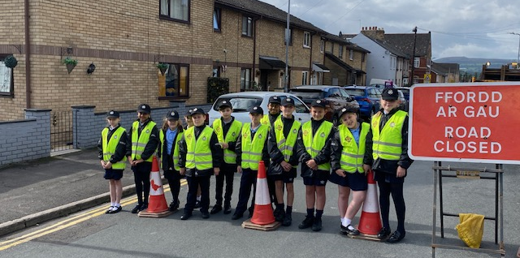

Friends of St Joseph’s
St. Joseph’s has always had a thriving PTA but in the last few years things have been difficult, as it has for most charities. We would like to restart the Friends of St Joseph’s and we need your help to do it. In previous years they have been responsible for raising funds to buy reading materials, IT equipment, playground equipment and many treats for the children. They have done this through holding fun events for the children and their families, such a film nights, discos, quizzes and barbecues. We are keen to continue with projects that will raise money for the school, so your children will benefit. We need new members if this is going to continue and we are grateful for any help that you can give. There is no obligation to be a part of every event, it can be shared out with ‘many hands making light work’ and ultimately it your children who benefit. Please complete the Google form sent out this week.

TRAINING DAYS 2023- 2024
Fri 20th October 2023
Fri 22nd December 2023
1 more training day TBC
Bank Holidays (School Closed)
6th May 2024 May Day

Please keep looking at diary dates as more will be added as the term progresses and we do not want you to miss out on any events that will involve your children.

