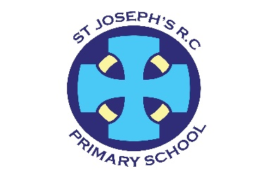
Newyddion Josef Sant
St Joseph’s News
Fairoak Avenue
Newport
NP19 8FW
01633 258801
Stjosephsrc.primary@newportschools.wales
Headteacher: Tara Lynch
6th May 2024

% Attendance – whole school – 93.4% TARGET 94%
Week ending- 3rd May 2024
Rec | Y1 | Y2 | Y3 | Y4 | Y5 | Y6
94.5% | 91.5% | 94.2% | 94.5% | 95.4% | 92% | 92.4%


Bank Holiday
School is closed on Monday 6th May

Preloved/spare uniform
We are still collecting uniform, please drop it into the office or give items to your child’s class teacher.

YR assembly
What a wonderful assembly Reception class. Well done! You have grown in confidence so much this year!

Gilwern
Well done to our children who represented our school perfectly! You all had a wonderful time and are suitably tired- we hope! Thank you to the staff – I bet you are tired too!
Mending Workshop
On Wednesday 8th May 2024, you are invited to come to the school hall for a sewing workshop at 2pm. Miss Hughes has kindly offered to teach parents and carers who are interested how to fix school uniform in a few simple steps to save money and reduce waste. She is happy to show you how to sew on missing buttons, how to fix hems that have come down, how to darn to mend a hole and how to make trousers into shorts for summer. If many of you are interested, we would also be looking for volunteers who can sew a little to support Miss Hughes. Please bring along your items that need fixing on the day! Please could you fill in the Google form below to express an interest in attending this workshop, or to offer your services as a volunteer. https://forms.gle/DCe55k9bBDxvK8Zy5

Thank you
Thank you to the Friends of the School who very kindly paid for the Pantomime this week. It was great!

Viral Infection
There are a number of schools in Newport reporting viral infections that could be slapped cheek. We have had a few children showing symptoms but they have not been diagnosed by a GP as slapped cheek. We have added the guidance for you to read. https://www.nhs.uk/conditions/slapped-cheek-syndrome/. If you need more information phone 111 or get in contact with your doctor.

End of the day
Please could we ask that children do not climb or swing on the metal bars outside the school office and outside the Year 2 and Reception classes. They are very slippery and not play equipment.

Calendar Dates
Weds 15th April –Weds 15th May | Gateway Rugby Y5 (St George)- Every other week
Thurs18th Apr- Thurs 9th May | Y2 (St Francis) County in the Community - weekly
Mon 6th May | Bank Holiday – School closed
Weds 8th May | Mending Workshop - hall
Thurs 16th May | Y2 Road Safety Workshop
Thurs 16th May – Thurs 13th June | County in the Community – Y1 (St Dwynwen)
Mon 20th May – Fri 24th May | Healthy Living Week 1
Fri 24th May | Caffi Cymraeg – hall 9am
Mon 27th May – Fri 31st May | HALF TERM
Mon 3rd June | Return to School
Mon 3rd June – Fri 7th June | Healthy Living Week 2
Thurs 6th June | Y2 Road Safety Workshop
Weds 12th June | Class Photographs
Thurs 13th June | Y2 Road Safety Workshop
Fri 14th June | Rags to Riches clothes collection
Mon 17th June – Fri 21st June | Refugee Week
Thurs 20th June- Thurs 11th July | County in the Community YR – (St Paul)
Fri 28th June | Training Day – school closed to pupils
Mon 1st July | Training Day – school closed to pupils
Thurs 4th and Fri 5th July | Y6 (St Teresa) Transition Days @ SJHS
Tues 9th July | Year 5/6 Production – Year 5 parents invited. (pm)
Thurs 11th July | Year 5/6 production Year 6 parents invited. (pm)
Fri 19th July | End of term

Welsh Phrase of the Week
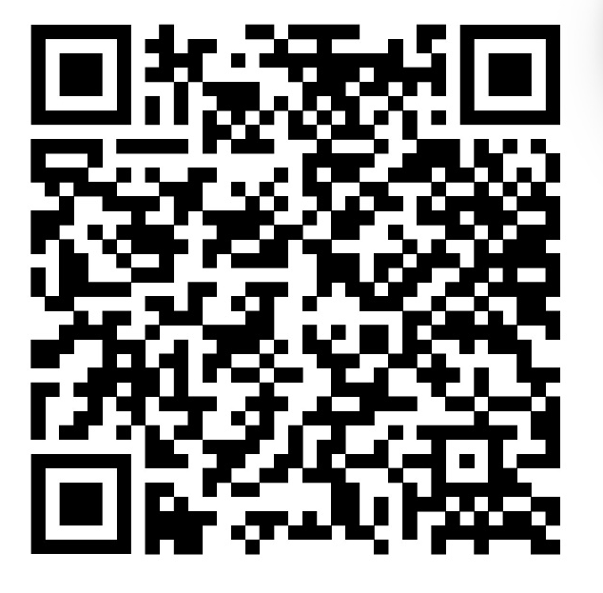
Cerddwch gyda fi, which means Walk with me in English.

Please keep looking at diary dates as more will be added as the term progresses and we do not want you to miss out on any events that will involve your children.
Training days (school closed to children)
Fri 28th June 2024
Mon 1st July 2024
Bank Holidays (School Closed) Monday 6th May 2024

