
Newyddion Josef Sant
St Joseph’s News
Fairoak Avenue
Newport
NP19 8FW
01633 258801
Stjosephsrc.primary@newportschools.wales
Headteacher: Tara Lynch
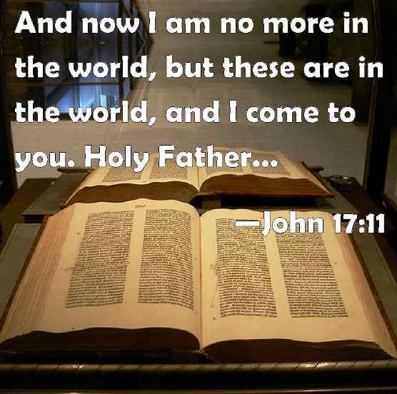
13th May 2024

% Attendance – whole school – 93.5% TARGET 94%
Week ending-10th May 2024
Rec | Y1 | Y2 | Y3 | Y4 | Y5 | Y6
94.5% | 91.5% | 93.9% | 94.6% | 95.5% | 92% | 92.7%

7th Sunday of the Year (B)
John 17: 11-19

Culture and Diversity Day
On Tuesday 14th May, the whole school will be celebrating the many cultures and languages represented in our school, through various learning activities. On the day, the children are invited to dress in clothes that represent their culture, for example, they may wish to wear traditional clothing, a national sports kit or the colours of a country’s flag.

Maths Day 21st May
The whole school will be taking part in Maths Day on 21st May – the children will be taking part in a variety of number and Maths related activities – we will send out more information next week.

Healthy Living Fortnight
20th – 24th May and 3rd - 7th June
This year we have 2 weeks to celebrate healthy living. Children will be finding out about how to keep their body and mind healthy. They will also be learning about nutrition and exercise. Throughout the fortnight, we will have a variety of visitors who will teach us a new game, sport or activity. For these 2 weeks children can wear PE clothes to school.

FP Sports Day – Wednesday 5th June
Foundation Phase Reception, Year 1 and Year 2 will be taking part in Sports Day during Healthy Living Fortnight. They will need to wear PE kit with trainers. Unfortunately, we are unable to accommodate parents to spectate. If the weather is fine, please ensure the children wear a hat and apply sun cream before school. Please pack sun cream for them to apply in the afternoon, as they will be outdoors all day. If the forecast is rain, please pack a raincoat. If you would like the school kitchen to provide a sandwich, please let Mrs Conlon know by Monday 3rd June.

Calendar Dates
Weds 15th April –Weds 15th May | Gateway Rugby Y5 (St George)- Every other week
Thurs18th Apr- Thurs 9th May | Y2 (St Francis) County in the Community - weekly
Thurs 16th May | Y2 Road Safety Workshop
Thurs 16th May – Thurs 13th June | County in the Community – Y1 (St Dwynwen)
Mon 20th May – Fri 24th May | Healthy Living Week 1
Fri 24th May | Caffi Cymraeg – hall 9am
Mon 27th May – Fri 31st May | HALF TERM
Mon 3rd June | Return to School
Mon 3rd June – Fri 7th June | Healthy Living Week 2
Thurs 6th June | Y2 Road Safety Workshop
Tues 11th June | Y1 Class assembly 2.45pm parents invited
Weds 12th June | Class Photographs
Thurs 13th June | Y2 Road Safety Workshop
Fri 14th June | Rags to Riches collection
Mon 17th June – Fri 21st June | Refugee Week
Thurs 20th June- Thurs 11th July | County in the Community YR – (St Paul)
Fri 28th June | Training Day – school closed to pupils
Mon 1st July | Training Day – school closed to pupils
Thurs 4th and Fri 5th July | Y6 (St Teresa) Transition Days @ SJHS
Tues 9th July | Year 5/6 Production – Year 5 parents invited. (pm)
Thurs 11th July | Year 5/6 production Year 6 parents invited. (pm)
Fri 19th July | End of term

Welsh Phrase of the week
Scan the qrcode below and practise the phrase.


Please keep looking at diary dates as more will be added as the term progresses and we do not want you to miss out on any events that will involve your children.
Training days (school closed to children)
Fri 28th June 2024
Mon 1st July 2024

