
Newyddion Josef Sant
St Joseph’s News
Fairoak Avenue
Newport
NP19 8FW
01633 258801
Stjosephsrc.primary@newportschools.wales
Headteacher: Tara Lynch
20th May 2024

% Attendance – whole school – 93.6% TARGET 94%
Week ending-17th May 2024
Rec | Y1 | Y2 | Y3 | Y4 | Y5 | Y6
94.6% | 91.3% | 94.3% | 94.6% | 95.6% | 91.7% | 93%
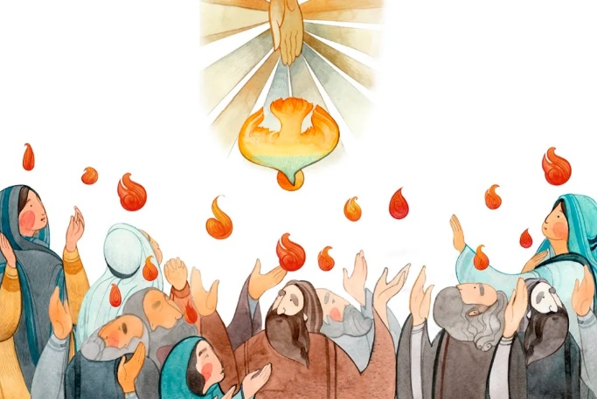
Diary Dates
Please look closely at the diary dates - more trips and activities have been added.


Culture and Diversity Day
We had an amazing day celebrating the diversity of this wonderful school. Thank you to the staff, parents, families and children for making this so special!

Maths Day 21st May
The whole school will be taking part in Maths Day on 21st May – the children will be taking part in a variety of number and Maths related activities.

Healthy Living Fortnight
20th – 24th May and 3rd - 7th June
This year we have 2 weeks to celebrate healthy living. Children will be finding out about how to keep their body and mind healthy. They will also be learning about nutrition and exercise. Throughout the fortnight, we will have a variety of visitors who will teach us a new game, sport or activity. For the next 2 weeks children can wear PE clothes to school.

FP Sports Day – Wednesday 5th June
Foundation Phase Reception, Year 1 and Year 2 will be taking part in Sports Day during Healthy Living Fortnight. They will need to wear PE kit with trainers. Unfortunately, we are unable to accommodate parents to spectate. If the weather is fine, please ensure the children wear a hat and apply sun cream before school. Please pack sun cream for them to apply in the afternoon, as they will be outdoors all day. If the forecast is rain, please pack a raincoat. If you would like the school kitchen to provide a sandwich, please let Mrs Conlon know by Monday 3rd June.

Mock High School Week -17th June
This is a wonderful week when children from Year 6 have a flavour of what it is like in High School. They have timetables, they have to find their way to lessons and they take all their belongings with them, all with adult support. We have teachers from the high school coming in to teach ‘high school type’ lessons. You will all have
more information in the following weeks.

Calendar Dates
Thurs 16th May – Thurs 13th June | County in the Community – Y1 (St Dwynwen)
Mon 20th May – Fri 24th May | Healthy Living Week 1
Tues 21st May | Maths Day
Tues 21st May | PTFA meeting – all welcome
Thurs 23rd May | Y1 - Animals Interactive
Turs 23rd May | Y2 Road Safety Workshop
Fri 24th May | Caffi Cymraeg – hall 9am -Year 2 are supporting
Mon 27th -Fri 31st May | HALF TERM
Mon 3rd June – Fri 7th June | Healthy Living Week 2
Mon 3rd June | Return to School  Eco Day
Weds 5th June | YR, Y1 and Y2 Sports Day  New Reception Intake meeting 5pm
Thurs 6th June | Y2 Road Safety Workshop  PTFA – Friends of St Joseph’s meeting 2.30pm all are welcome
Tues 11th June | Y1 Class assembly 2.45pm parents invited
Weds 12th June | Class Photographs
Thurs 13th June | Y2 Road Safety Workshop  Fluoride Treatment – YR, Y1 and Y2 – more information to follow
Fri 14th June | Rags to Riches collection  St Joseph’s Summer Fete - 2pm all welcome more details to follow
Mon 17th June – Fri 21st June | Refugee Week and Mock High School Week
Thurs 20th June- Thurs 11th July | County in the Community YR – (St Paul)
Thurs 20th June | Year 2 Trip – Bush craft Skills
Fri 21st June | YR Trip - Noah’s Ark Zoo Farm
Mon 24th June- Thurs 27th June | Year 6 Bike Safety Workshop
Thurs 27th June | Y4 Class assembly - 2.45pm parents invited
Fri 28th June | Training Day – school closed to pupils
Mon 1st July | Training Day – school closed to pupils
Tues 2nd July | Y1 trip - Wetlands  Y3 assembly SS Peter and Paul Service 2.30pm parents invited  Y4 trip – Tredegar House and Park
Thurs 4th and Fri 5th July | Y6 (St Teresa) Transition Days @ SJHS
Tues 9th July | Year 5/6 Production – Year 5 parents invited. (pm)
Weds 10th July | Year 5 Transition Day at SJHS – more details to follow  Y3 trip - Castell Henllys
Thurs 11th July | Year 5/6 production Year 6 parents invited. (pm)
Fri 12th July | Year 5 Trip – Royal Mint  Year 6 Trip - Twmbarlwm
Fri 19th July | End of term
The Friends of St Joseph’s PTFA meeting
We are holding a PTFA meeting on Tuesday 21st May at 4.30pm.
If you would like to get involved helping to fundraise for the children, please come along.
The meeting will last for no more than an hour. If you can’t attend and would still like to help, please email school.

Dinner bookings
Due to the half term holiday, please ensure that your dinner bookings are completed by Sunday 26th May for the week beginning 3rd June.

Welsh Phrase of the week
Scan the qr code below and practise the phrase.

Mae’n amser cinio!
It’s dinner time!

Please keep looking at diary dates as more will be added as the term progresses and we do not want you to miss out on any events that will involve your children.
Training days (school closed to children)
Fri 28th June 2024
Mon 1st July 2024

