
School Prospectus 2025 - 2026

Dear Parents/Carers,

We warmly welcome you and your child to St. Joseph’s Catholic Primary School. Choosing the right school for your child is one of the most important decisions you will make. The purpose of this prospectus is to help you make that choice and to give you information about our school.

St. Joseph’s is a thriving, friendly school dedicated to the success of its children. We provide full-time education, currently for 210 children between the ages of 4 and 11 years. We are a Roman Catholic, Voluntary Aided school in the trusteeship of the Archdiocese of Cardiff. We strive to promote an inclusive system and are committed to working for equality of opportunity.

We are a Catholic school where pupils, parents, staff, governors, parish and community, work together to create a happy, stimulating, inspirational and safe environment in which all children are motivated and encouraged to care for each other, become independent learners, capable of achieving the success they deserve. We aim to encourage the moral, social, intellectual, emotional and cultural development of each and every child. For this to happen, we realise that our children must be valued and given the respect they deserve, and in turn that they value and respect others. They are encouraged to take responsibility for their own actions and to be tolerant of others. We value the opinions of our pupils which shape the vision and running of the school through initiatives such as the School Parliament where children from Year 2 upwards belong to one of nine ministries which help to improve all areas of school life. We recognise that we are all individuals who learn in different ways, therefore teaching and learning will be of a high standard involving a variety of approaches, ensuring everyone reaches their full potential, including vulnerable groups.

Whilst the school and parish have crucial roles in the education and growth of each child, St Joseph’s recognises parents are the first teachers and the greatest influence in a child’s life. We believe that we can only achieve the best for your child through a close partnership with home. We believe that this improves the level of co-operation and the sense of shared commitment and responsibility. We hope that parents will take a close interest in what their children are doing in school and will encourage learning and its importance in later life.

We aim to provide a welcoming atmosphere that encourages you to come and discuss any difficulties, problems or uncertainties where the education and wellbeing of your child is concerned. We look forward to working with you and your child and to your involvement in the life of the school.

We would be pleased to have the opportunity to show prospective parents around our school where the atmosphere and ethos can be experienced first-hand.

Mrs Tara Lynch Mrs Annette McHugh
Head teacher Chair of Governors

Head teacher | Mrs Tara Lynch
Chair of Governors | Mrs Annette McHugh
School Name | St Joseph’s R.C. Primary School
School Address | Fairoak Avenue,  Maindee,  Newport,  NP19 8FW
Telephone Number | 01633 258801
Email Address | stjosephsrc.primary@newportschools.wales
Website address | www.stjosephsprimarynewport.co.uk

Table of Contents
School Contact Details
Letter from the Head teacher
Mission Statement, Objectives and Strategy for Achievement
Admissions Policy
Location of the school and accommodation
The School Community | - Pupils and Class Organisation  - Staff  - The School Parliament  - The Governors  - Parents/Carers  - Home School Links  - Home School Agreement  - The ‘Friends of St. Joseph’s’  - Links with All Saints Parish  - Links with the community  - Links with the feeder nursery and secondary school
Transition | - Newport Nursery School  - St Joseph’s High School
The School Day | - Start of the Day Routines  - End of the Day Routines
Attendance | - Attendance  - Punctuality  - Holiday Requests  - Dates for the academic year 2025-2026
The School Curriculum | - Curriculum Statement  - Principles of Teaching and Learning  - Progression Steps 1-3
Creative Curriculum | - Each term Themes are agreed upon by each key stage.  - The key stages work together to provide creative and stimulating opportunities for the pupils to develop both skills and knowledge alongside a relevant context.
Assessment | - Assessment  - Target Setting
Inclusion | - Additional Learning Needs (ALN)  - Accessibility  - More Able and Talented  - Equal Opportunities  - Race Equality
School Uniform | - Uniform  - PE Uniform  - Jewellery
School Discipline and Behaviour | - Golden Rules  - Class Rules  - Organisation and Routines  - Lunch time  - Reward and Consequences  - Exclusions
Healthy Eating | - Lunch times  - Meals  - Dinner Money  - Free School Meals Entitlement  - Healthy Schools
School Events
Extra-Curricular Activities
Educational Visits
Charging Policy
Children’s Health and Welfare | - Pastoral Care  - Child Protection  - Illnesses  - Accidents and Emergencies  - Medicines in School
Health & Safety
Emergency Telephone Numbers
Medical Information
Safety
Your child’s First Day in School
Complaints
Schools Performance and Target Information

Our Mission Statement

Believe in God, ourselves and others
Belong to a school family that grows together in faith and love
Become disciples who are empowered to wonder, discover and learn

St Joseph's School was built in 1896 to meet the needs of the growing Catholic population on the East side of Newport. The school serves the community of All Saints Parish, Newport, St Julius the Martyr and Ss Julius, Aaron and David Parishes. It exists to provide and sustain an environment where the beliefs and values of the Catholic faith are developed and nurtured. The school is a vital and formative part of the mission of the church in the area. As God Our Father is the centre of everything, we place God at the centre of our learning, teaching and achievement.

Each individual has a unique place in the eyes of God regardless of race, class, wealth or ability. This means that the educational process is viewed not simply as a human activity, but as a Christian journey towards perfection. The school is there to present the children with the synthesis of faith and culture that will help them along this path. As the child grows spiritually crucial opportunities arise when parents also can be helped to assess the stage of their own spiritual development and to reassess their relationship with God.

The Sacraments of Reconciliation and First Holy Communion are times when the priests, parish and school combine to welcome and assist those on their journey of faith. The school is a living testimony to Christ’s teaching, reflected in every aspect of school life.

The Shared Aims of the School

We are virtuous, fruitful disciples, who:

- Want to communicate with God in prayer, to thank Him, to say sorry, to praise Him and to ask for help
- Are empathetic and compassionate to all, and caring custodians of God’s creations
- Use our skills, talents and knowledge to spread the word of God
- Aspire to be faithful and truthful throughout our lives by growing to be like Jesus, the saints and prophets.
- Learn, work and worship together as a community of faith
- Make time for meditation and reflection and wait patiently for a reply or a sign from God.
- Respect and are knowledgeable about all faiths, cultures and religions and seek dialogue and mutual understanding
- Belong to God’s family and our lives are shaped by the people of God, their stories and messages that inspire us
- Are part of a warm and welcoming school family who nurture and value all qualities and celebrate successes and achievements equally
- Are proud citizens of Wales and the world who embrace our local, national and global heritage.
- Have the confidence to overcome challenges and use our voices to become well-informed, independent and resilient learners
- Look after our bodies and minds and know how to be active, happy and healthy in all aspects of our life
- Acquire the skills needed to adapt to an ever-changing world with rapidly evolving technologies to become lifelong learners
- Allow all pupils to grow in personality character and faith in a safe and caring environment

...and are ready for any mission God will give us.

ADMISSIONS Policy and Application Form (Please see website for full policy)

The School's Location and Accommodation

The school is situated in a pleasant residential area on Fairoak Avenue, Newport. Whilst the original building is Victorian the school has benefited from major refurbishment in 1996 which also included a new hall, kitchen and infant classrooms. The interior of the school has been maintained to a very high standard.
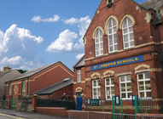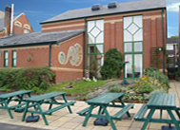

The building comprises of:

The Administrative Section:
- a reception area for adults and visitors, secretary’s office with the Head teacher’s office along the corridor

Classrooms/Resource Rooms:
- seven generously appointed classrooms – of which two have immediate access to the outdoors; an outdoor classroom, a support room, a resource room for staff and an infant resource room.

Other:
- a large hall, kitchen, a staff room, cloakrooms for infant classes, junior and staff toilet facilities.

External Facilities

Infant Playground: This is divided into areas for play and enhanced with a canopy, trim trail and an undercover seated area.

Junior Playground: A tarmac area with picnic benches, a decked area, a surfaced playground and a prayer garden.

Forest/conservation areas: Although this is off site, St Joseph’s staff were instrumental in obtaining and developing this facility for the use of our school and other schools in the area. These grounds are continuously being improved to increase biodiversity and to provide many opportunities for outdoor learning to enable us to implement the Foundation Phase, a skill-based curriculum and Forest Schools.

The School Community

The Pupils

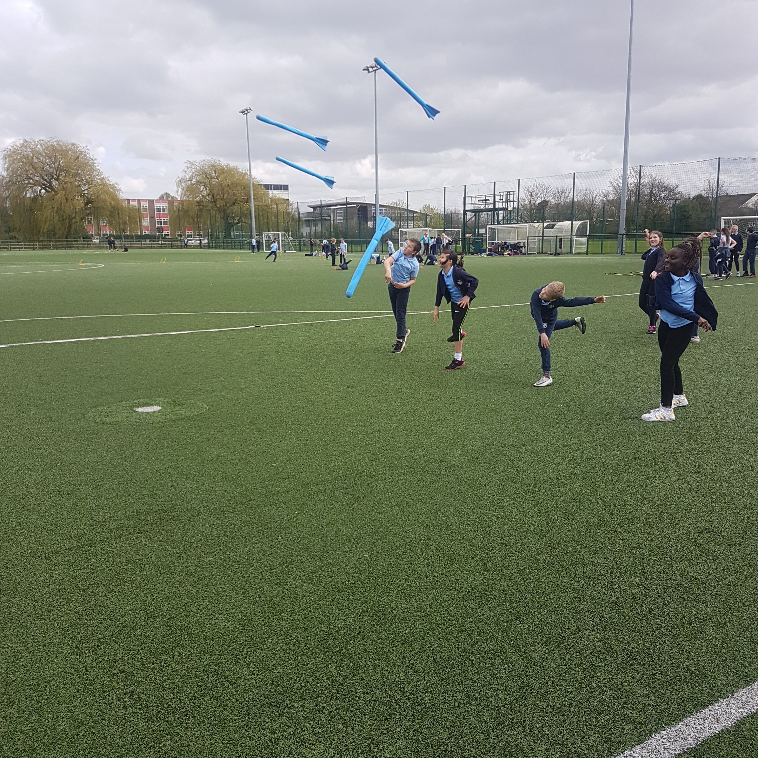

At present we have 210 pupils in the school aged 4-11 years. Our pupil admission number is 30. This usually means that children make up a class with pupils of their own age – we do not have any mixed year groups in the school at present.
Each phase will no longer be known as Foundation Phase and Key Stage 2, but as the below examples:
Progression Step One : Reception (and nursery)
Progression Step Two: Years 1, 2 & 3
Progression Step Three: Year 4, 5 & 6

Class Organisation
Pupils in the school will be organised into seven classes as follows for September 2024:
Reception
Year 1
Year 2
Year 3
Year 4
Year 5
Year 6

Staff Organisation 2024-2025
All teachers and teaching assistants are fully qualified to work with primary-age children and together have a wide, rich range of experience, skills and knowledge, which they bring to the school.

Teaching Staff | Ancillary Staff
Head teacher Mrs T Lynch  Deputy Head teacher Mrs V Bradshaw  Mrs S Waters  Mrs A Beckett  Mrs J Blanks  Mrs G North  Mrs R Jenkins  Mrs S Jones  Miss E Thomas | Miss V Hughes  Mrs A Sellick  Miss O Rowberry  Mrs R Bailey  Mrs M Adams  Miss H Beckett  Miss O Beckett  Ms M Anderson  Mrs T Conlon -School Support Officer  Mr A Sullivan - School Caretaker  Miss J Smith- School Cook (Chartwells)

Specialist music teachers
Specialist music teachers visit the school during the week to provide tuition in selected instruments – Strings (Y1-6), Woodwind (Years 3-6), Brass (Years 3-6), Piano (Years 2-6).

The School Parliament
Our School Parliament is made up of groups of pupils from Year 2 upwards who belong to one of nine ministries. The ministries include – Mission, Eco, Communication, Criw Cymraeg, Digital Leaders, Guardian Angels, Curriculum, Chaplaincy and Healthy Living ministries. Each group elects a chair and a secretary and the whole school elects a Prime Minister and a Deputy. The pupils work alongside the staff to represent the views of all pupils and to improve their school. Cabinet meetings are held every two weeks with the head teacher to feedback ideas, suggestions and initiatives.

Buddies
At St. Joseph’s we operate a unique ‘Buddy’ System with Year 6 and Reception children. This relationship begins in the summer term when the new to school children are still in nursery and the school children are still in Year 5. Visits are arranged to the nursery where the older children have the chance to meet the children coming to St. Joseph’s. The teachers observe the children’s interaction and match up the older and younger children. Back in school the children write a letter to their buddies telling them about themselves and they attach a photograph.
When the nursery children visit the school, the children meet up and have time together in the Reception class area.
When the new children begin school their buddy will be there to help them settle in. They will meet them at the school gate, support them as they settle in, spend time with them in their classroom, sit with them when they first start attending assemblies and basically look out for them.
St. Joseph’s has developed this system over the past 7 years and it has been invaluable in helping the new children to settle in; in developing the nurturing and caring side of the older children; and also, in reassuring parents as they leave their children at the school gates.

The Governing Body
The Governing Body plays a key role in deciding the school’s strategy so that the children learn effectively and achieve the highest standards. The Governing Body also provides the head teacher and staff with support, challenge, advice and information.

Chair of Governors | Mrs A. McHugh(Foundation)
Vice Chair of Governors | Mr. C. Reynolds (Foundation)
Head teacher | Mrs T Lynch
Foundation Governors | Mrs J. Llewellyn  Miss B. McNulty  Sr Geraldine Chidgey  Mr P. Brunnock  Mrs E Johnson  Mrs A O’Brien  Mr C Oates
Parent Governor | Mrs C Pullen  Mr M Tahir
Teacher Representative  Non-teaching representative  Co-opted Member | Mrs J. Blanks  Mrs T Conlon  Mrs V Bradshaw
Local Education Authority Representative | Mr M Pimm  Mr R. McDonald
Clerk to Governors | P Lambert

The School Day
The school gate opens at 8.45am with a Senior Teacher at the gate welcoming all the children through the school gate and into the playground where they are met by their class teachers.
Registration and dinners are recorded as soon as the children get into their classes and then assembly is held at 9.00 am.

Morning Break:
Flexible timings from 10am – 11am

Lunch break:
Years R, 1 & 2: 12.00 noon -1.00pm
Years 3, 4, 5 & 6 12.30pm - 1.30pm

The day ends at 3.20p.m. for Years R, 1 & 2 and 3.30pm for Years 3,4, 5 & 6.

The time spent on teaching during the normal school week, including RE but excluding the daily act of collective worship, registration and breaks is:
- 23 hours 45 minutes

Start of the day
Staff are on duty at the gate and in the playground from 8.45am onwards. Pupils enter the school through the side gate and proceed to the playground. The side gate is to be used for children only. All adults and visitors to the school must enter the school through the main reception door at the front of the school. The side gate is shut at 8.55am. Any child entering or leaving the school premises after 8.55am must do so through the school Reception area. Pupils who are late for school are required to sign-in stating the reason for their lateness. These arrangements are in place to ensure the safety of our pupils during the school day whilst also ensuring parents have access to the school and are made feel welcome at all times.

End of the day
At the end of the day teachers bring Year R, 1 & 2 pupils to the doors that lead into the play yard. Parents are encouraged to wait in the yard to collect their children who will be guided towards them. The teachers bring older children to the front of the school. Parents who wish to speak to their child’s teacher may do so then if it will be brief. If a longer discussion is required, an appointment can be made. If there are any changes to the arrangements in place for collecting a child the school will notify you in advance. Please let us know in advance if someone else will be picking up your child or you need to pick them up early for any reason.

At present we have 210 pupils in the school aged 4-11 years. Our pupil admission number is 30. This usually means that children make up a class with pupils of their own age – we do not have any mixed year groups in the school at present.

Voluntary Aided Status
St. Joseph’s Voluntary Aided status means that Governors have certain responsibilities. These include:

- ensuring Catholic teaching is included in the teachings of the school and liaising with the Parish Priest to help the school achieve this;
- determining the Admission Policy;
- employer of school staff;
- managing finances and
- owning and managing the school buildings including paying for maintenance and structural improvements.

Parents/ Carers and Home School Links
Parents are very welcome in the school and we value the important role they play in the education of their children. At St Joseph’s School there is a strong partnership between home and the school. Our experience has taught us that children make the most progress when parents are fully involved in their learning. It is important that children are happy and at ease with the education process. The more aware parents are of the work of the school, the easier it is to develop this. The school holds many events and workshops throughout the school year, when parents are invited into school to work with their children.

Parents are also encouraged to become involved in our active ‘Friends of St. Joseph’s’, to attend meetings, assemblies, Masses and other school events and to come into the classrooms as reading volunteers. Newsletters and other communications are sent out regularly via Parentmail to keep parents informed. Our Home – School Agreement is our shared commitment to working together.

Home school links
Parents' Visits
At various times throughout the year, formal invitations are sent to parents to visit the school. New intake meetings are held in May and September, the Annual Governors’ Report to parents is available on the website in the Autumn term. Class assemblies or masses are held termly. Parents are also invited through newsletters to all assemblies, concerts, Sports Days and ‘Friends of St. Joseph’s’ Events.

Weekly Newsletters
A Newsletter is sent out every week on a Friday via Parent Mail. This includes things that have taken place that week, what is expected to happen the following week as well as notifications and dates for the future. Please ensure you have set up Parent Mail as this is our main form of communication with you.

Information Evenings
These are usually held in the first few weeks in September. The teacher outlines what the pupils will be learning during the year and explains how systems work in that particular class e.g. homework, PE days, reading etc. Teachers provide parents with an overview of what pupils will be learning. This is also a chance for parents to ask questions about the new class and express any concerns.

Parent-Teacher Consultations
These are held twice yearly, usually approximately halfway through the Autumn Term and towards the end of the Spring Term or early in the Summer Term. Each consultation lasts approximately 10 minutes. In the Summer Term, a written report is sent home. Any parent who has any concerns about their child is encouraged to contact the school to make an appointment to see the class teacher/support teacher/Head teacher for an extra consultation to be arranged.

Parent Consultations/Clinics for Pupils with Additional Educational Needs
Each term parents of children who have Individual Development Plans (IDPs) are offered an additional meeting with the class teacher, the ALNCO Additional Learning Needs Coordinator, Mrs Jones and other staff who work with your child. Staff will review the targets set for the pupils with the parents and set new targets for the new term. Pupils will also contribute how they feel they are progressing.

Home Learning
Children may be given tasks to perform at home to support classroom learning. Sometimes class teachers will ask parents to practise specific tasks with their child in addition to regular home learning.

Home learning may include learning multiplication tables, spellings, or tasks specific to subject areas including project work and IT based work (please let us know if your child cannot access a computer/tablet at home). Parents are asked to help their children with these activities in a constructive way to support their learning. Parents are asked to listen to and/or read with their children "little and often’’ 10-15 minutes 5 days a week before bedtime each day is ample.

eLearning
As there is more and more emphasis on digital learning, many tasks need to be completed online using programmes like Seesaw and Mathletics, which the school has invested in for pupils to access both at home and in school. Google and Hwb are also used to share work and encourage collaboration.

Newsletters
Newsletters are emailed through Parent Mail weekly and are put on the website. It is important to read these weekly as they inform parents of events happening in the school and the community.

Other
Parents are always welcome in the school to help with activities such as reading groups, art activities and within classrooms. Help is often required on trips and with transport to matches, etc. Parents with particular expertise can also make a positive contribution to school life. Please contact the Head teacher if you are able to help in school. Any parents who volunteer to help must be willing to undergo a DBS check (formerly CRB) which we must undertake for child protection reasons.

Home-school Agreement
The ‘Home School’ agreement seeks to embody the aims and values of the school. It covers the areas in which we can effectively work together, encapsulating partnership between pupil, parent and teacher. All parents, pupils and staff are required to sign the Home-school agreement annually. The home school agreement has been ratified by the Governing Body and reflects our mission statement.

The Friends of St. Joseph’s
We have a very active and hardworking Friends of St Joseph’s (P.T.F.A) who organise fundraising events to provide resources for the school. The Annual General Meeting is held in September each year and all parents are welcome. This body is elected by the parents and forms a welcome and vital part of our school life.

At this meeting we elect the Chairperson, Vice Chairperson, Secretary and Treasurer for the new academic year. All parents are invited to attend the monthly meetings and become actively involved in the school. Events are held throughout the year – Picnic, Fetes, Film Nights, discos and quiz nights. These events are always lots of fun for children, parents and staff and we are grateful for everybody’s support and assistance and trust that your interest and generosity will continue in the future.

Parish Links

Parishioners are welcomed into the school to attend assemblies, masses, and other school events. Children, staff and parents attend mass at St Mary’s Church termly throughout the year. Our Foundation Governors are our link between school and parish. Foundation Governors are actively involved in school life visiting the school on a regular basis. Our Chair of Governors, Mrs Annette McHugh, and Mr Charles Reynolds, our Vice Chair of Governors, are also Foundation Governors and active members of All Saints Parish. We are very fortunate to have such strong links and these have very beneficial to our pupils’ wellbeing, spiritual and moral development. There is a link to the parish website on our home page at www.stjosephsprimarynewport.co.uk.

The School and the Community
We have excellent links with local businesses and schools. Students from local colleges train to work with children at the school. Pupils visit the local library and sing in local nursing homes during the year. Pupils have participated in the Chartist March Re-enactment, an Evacuee Day, Apple Tree Planting in Woodland Park, The Holocaust Memorial Service, The Eton House Project and singing in various local community settings.

We have a well-established relationship with University of South Wales Initial Teacher Training Course. Throughout the year we welcome trainees to facilitate their school-based placements. We also welcome students for Coleg Gwent who are undertaking various courses to enable to take up roles as Teaching Assistants.

Transition

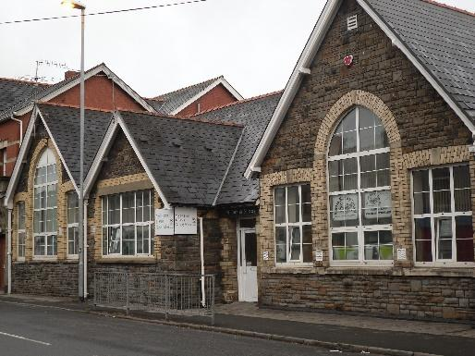
Newport Nursery
We are very fortunate to have Newport Nursery near our school site. We have excellent links with the nursery and we work closely on many initiatives throughout the year. Whilst the nursery feeds into many local schools most of our Reception pupils come from Newport Nursery. Strong links have been formed between the school and nursery and much good practice is shared between both.

Transfer to Secondary School – St Joseph’s Roman Catholic High School



All Catholic Primary Schools in Newport feed into St Joseph’s High School. We have very strong links with the High School and pride ourselves on a seamless transition between primary and secondary school. Year 5 & 6 pupils attend various events in the High School – Science Days, Gymnastic Days, Performing Arts Day and Masses.

Attendance, Punctuality and Absence

The Education Welfare Service
Why School Attendance Matters – from the Education Welfare Officer to the school

Regular school attendance is important for your child and the Education Welfare Service encourages parents to work in close partnership with the school to ensure good attendance and punctuality. Pupils are expected to attend school every day unless they are prevented from doing so due to illness. As a service if there are no specific justifiable reason for non-attendance at school this may result in legal action.
One of the strategies implemented to assist in raising attendance is First Day Absence Contact.

To assist with these strategies, we are seeking your support in: -
Contact the school on the first day of absence by telephone, email or Parent Mail, as soon as possible if your child is unable to attend school explaining the reason for the absence. This will ensure that your child is marked in the register as being on a "notified absence" (to meet Welsh Office regulations) and helps the office considerably. The office is required to ring parents if a message is not received.

Making doctor and dental appointments outside school hours whenever this is possible, but always letting the school know if you have an appointment for your child during the school time.

The Education Welfare Service discourage holidays being taken in term time and hope that whenever possible you will avoid this. A high attendance results in your child/ren achieving their potential and higher achievement. Missing school makes the work more difficult and relationships can break down with their peers. Please see the poster below:

UNDERSTANDING YOUR ATTENDANCE PERCENTAGE
These figures show the end of year percentage and
how many school days are missed.
LOW ATTENDANCE

POOR ATTENDANCE

91% = 18 days missed from school
90% = 20 days missed from school
89% = 21 days missed from school
88% = 23 days missed from school
87% = 25 days missed from school
86% = 27 days missed from school

96% = 8 days missed from school

95% = 10 days missed from school

94% = 12 days missed from school
93% = 14 days missed from school
92% = 16 days missed from school
EVERY
SCHOOL DAY COUNTS.
SCHOOL TARGET
94%

When you take 10 days holiday, you will only be able to achieve 95% by the end of the year.

If you have additional sick days and appointments during school time attendance will then fall below 94%.

Attendance is monitored regularly by the school and the Educational Welfare Service.
85% = 29 days missed from school
84% = 31 days missed from school
83% = 33 days missed from school
82% = 35 days missed from school

98% = 4 days missed from school
97% = 6 days missed from school

Absences are categorised as authorised and unauthorised.

Authorised absences are illness, special occasions e.g. Attendance at a funeral of a family member, religious observance days, exclusion

Unauthorised Absences are shopping, birthdays, late attendance after closure of the register, any other reason which is considered by the school to be unacceptable. Newport LA Education Welfare Officers provide support to schools, pupils and their parents to encourage regular school attendance.

Punctuality
Lateness is now an unauthorised absence according to Welsh Office regulations. Any late arrivals (pupils who arrive after the close of registration) will have to be marked in the register, which is a legal document, and reports made to the Education Welfare Service.

Punctuality is a vital life skill and it is important that children are encouraged to develop this. Pupils who arrive late often miss the beginning of lessons and find it difficult to catch up. Young children can become upset when this happens.

It is also important that children are collected on time at the end of the school day. Late collection can be distressing, especially for young children. The school needs to be informed in advance if a different adult is to collect a child at the end of the day. In addition, it is important that the school is notified if an adult expects to be a few minutes late. The Education Welfare Officer is available to offer practical support to any families experiencing problems with attendance or punctuality.

Unauthorised Absence Requests
If annual holiday is required in term time, please make a request to the school in writing on a ‘Unauthorised Absence Request’ form. The school do not authorise any holiday requests. You may be asked to make an appointment with the Head Teacher or member of the Senior Leadership Team to discuss the Unauthorised Absence Request. Parents are reminded that the beginning of the school year is a particularly important time for pupils to settle into their new class and that whole school assessment takes place in May, so these times are best avoided.

School Term Dates 2025- 2026

Autumn term
Starts: Monday 1 September 2025
Half term: Monday 27 October 2025 to Friday 31 October 2025
Ends: Friday 19 December 2025
Spring term
Starts: Monday 5 January 2026
Half term: Monday 16 February 2026 to Friday 20 February 2026
Ends: Friday 27 March 2026
Summer term
Starts: Monday 13 April 2026
Half term: Monday 25 May 2026 to Friday 29 May 2026
Ends: Monday 20 July 2026

School Inset days
- Training Days will be available via the school website and newsletters as soon as they have been decided.

The School Curriculum

Curriculum Statement
At St Joseph’s the curriculum is designed to fulfil the aims of our Mission Statement. In striving for excellence in education we look for both breadth and balance.

We particularly aim to develop self-esteem, a love of learning and a sense of personal responsibility through:
- the promotion of the full spiritual, academic, personal and social development of each individual;
- encouraging growing independence and pleasure in learning;
- encouraging children to develop lively enquiring minds and the will to persevere;
- fostering the ability to identify and to solve problems;
- ensuring the ability of children to work in cooperation with one another
- learning to both lead and to accept direction.
- learning to share.

Digital competence – Internet safety

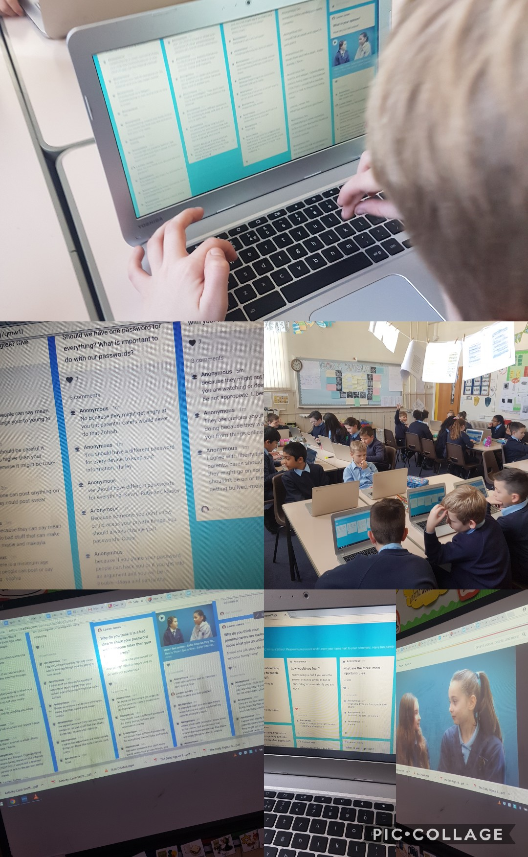

Curriculum

In September 2022 a new Curriculum was launched in all Welsh schools. For the past few years, schools have been upskilling, training, researching and trailing in preparation for this launch. St. Joseph’s will be continuing to move towards this new way of learning and a focus on four purposes.

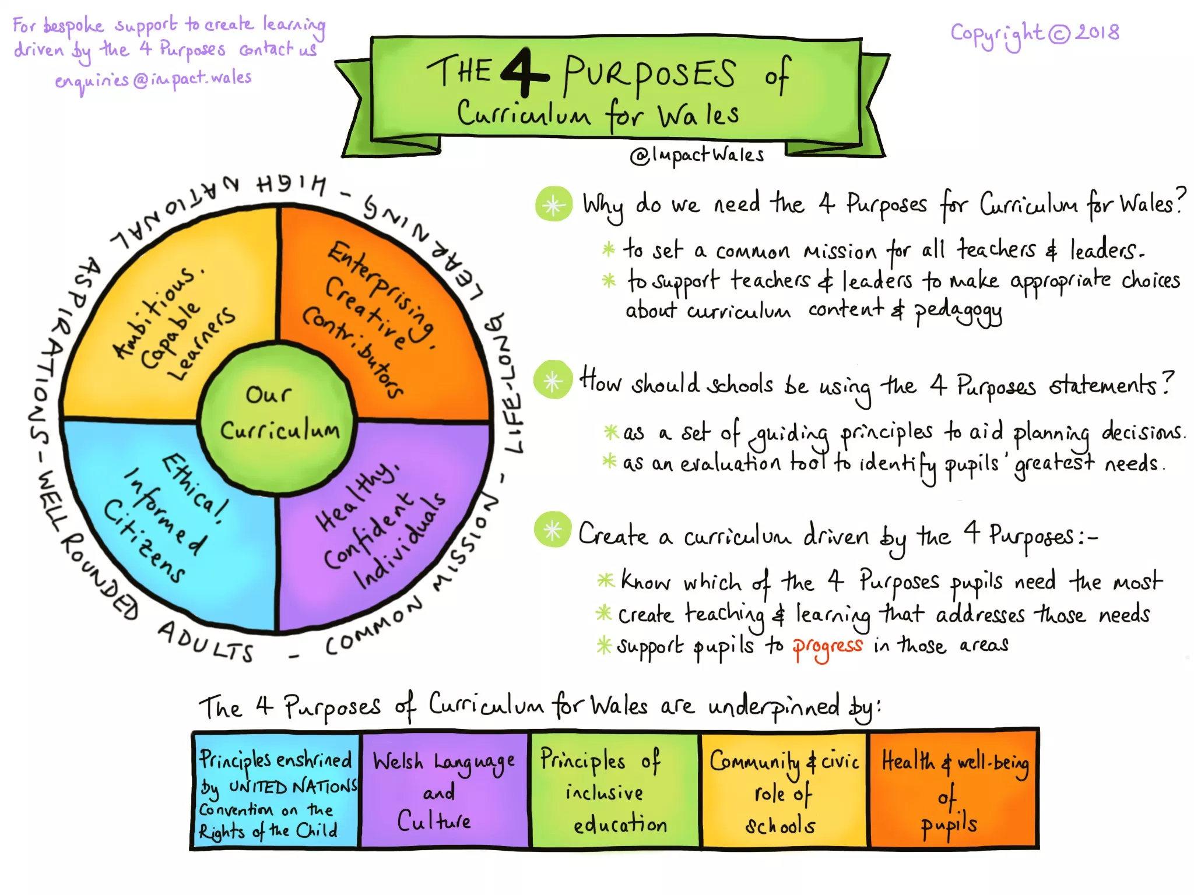

Your child will be encouraged to participate in a planned environment where the activities have been carefully structured to ensure that valuable learning is taking place.

The Areas of Learning Experiences that will be taught are as follows:
- Science & Technology
- Numeracy & Mathematics
- Language, Literacy and Communication
- Expressive Arts
- Health & Well-being
- Humanities

For details on the full curriculum please follow this link:
https://hwb.gov.wales/curriculum-for-wales

Curriculum development in St. Joseph’s

Humanities
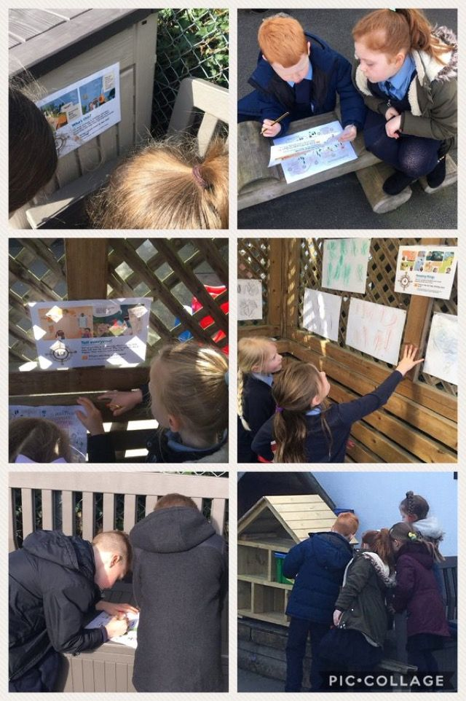
Numeracy & Mathematics
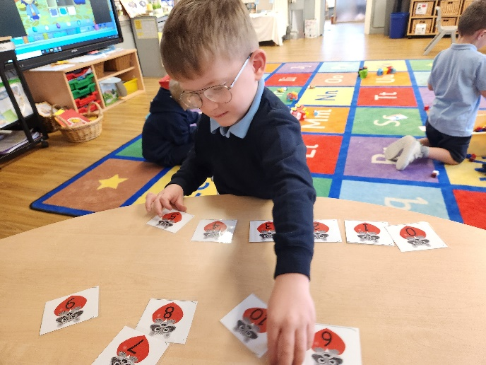 Ordering numbers 1 - 10
Languages, Literacy & Communication
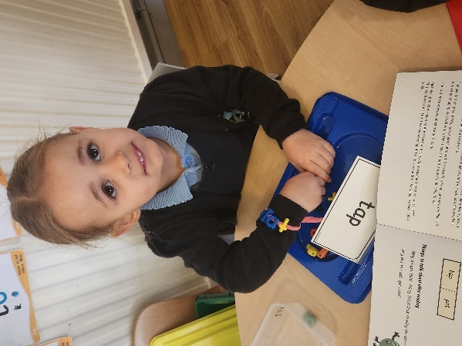 Word building with Monster Phonics

Religious Education

Religious Education is provided through positive Catholic teaching. The Religious Education programme ‘In God’s Name’ is used based on the liturgical year and the importance of gospel teachings.

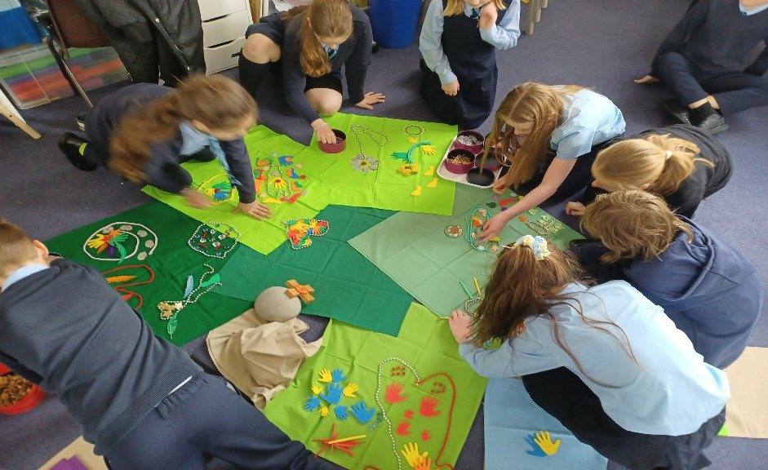

Science & Technology

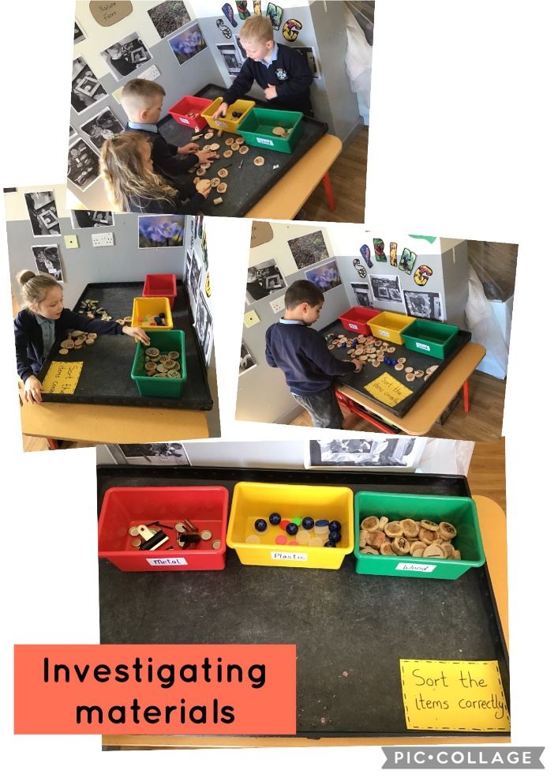
Expressive Arts
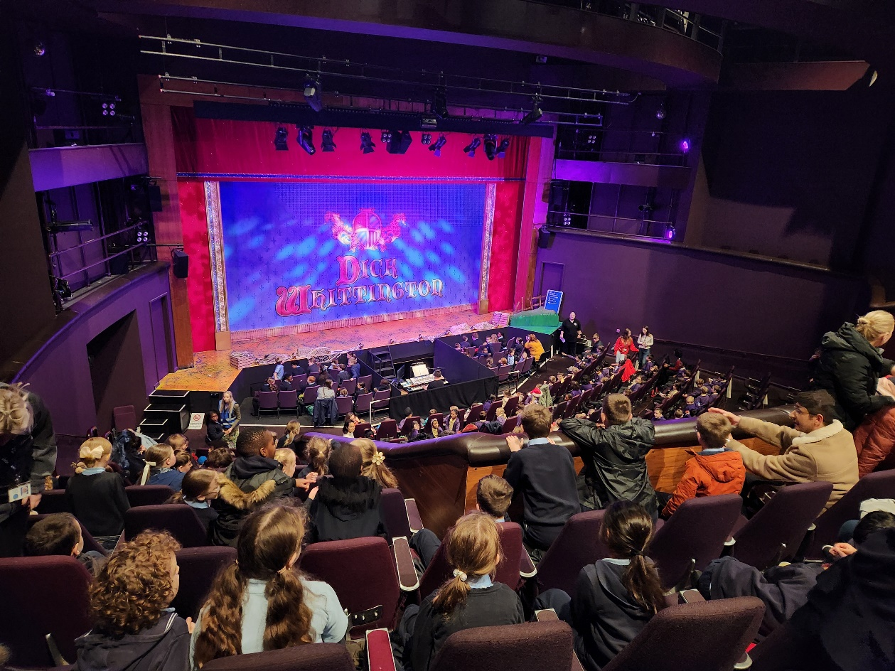
Whole school visit to the Pantomime at the Riverfront Theatre

Health & Wellbeing

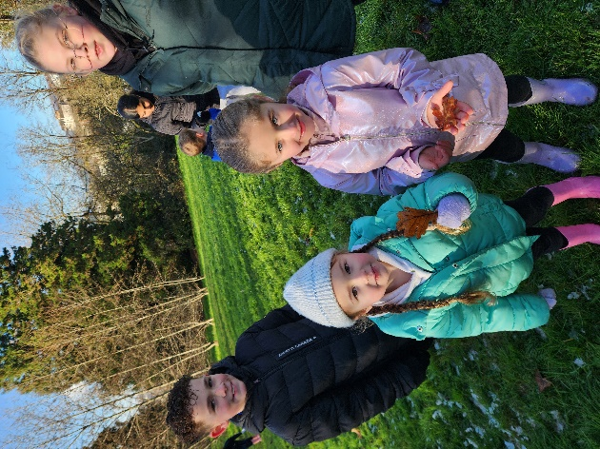
Forest Schools Visit to Woodland Park – Reception Children and Year 6 Buddies.
Relationships and Sex Education (R.S.E.)

The main emphasis is on relationships and will reflect the needs of pupils as they develop and move through the school. From early in Progression Step1 the teachers will use the correct terminology for parts of the body and will teach this in a sensitive and appropriate manner. It is essential that our children understand that some things are inappropriate and with the parents' support we will help to teach the children that there are parts of their body that they keep covered. The school teaches about fertility, conception and birth in Year 6. We use a variety of materials to support these lessons, one of which is Fertile Heart. This programme is founded on the beliefs of the Catholic Church and encourages young people to see beauty differently and to understand the values of human connection and self-worth. Parents will be notified when the sexual education lessons are due to take place. This includes physical and emotional changes during puberty and the effect of drugs on the Human Body. All teachers answer any questions as appropriately as possible.

Assessment

All children are constantly assessed in a variety of ways throughout their time in school. There are a variety of forms of assessment:
- Assessment for Learning (Formative Assessment) ...
- Assessment of Learning (Summative Assessment) ...
- Comparing Assessment for Learning and Assessment of Learning. ...
- Assessment as Learning.
Parents/guardians will receive a full report at the end of the school year and will have the opportunity to speak to teachers in the Autumn and Spring terms. Teachers will use the assessment information to feedback to parents/guardians on progress and next steps.
Currently, pupils in Years 2, 3, 4, 5 & 6 complete National Numeracy, Reasoning and Reading Tests. This data is used as part of our internal school tracking and is no longer used or reported to Welsh Government. Continuous assessment is discussed and shared with the pupils as an integral part of their learning. These daily conversations which look at their work, discussions about next steps in learning, providing challenges for the pupils and by sharing with the children where they are and what they can do to improve enable learners to become more reflective and take ownership of their learning by understanding their learning styles, what they do well and how they can improve. This also enables teachers to plan the most appropriate learning opportunities for the pupils and ensures that all children have the best possible opportunities to improve.

Inclusion
Additional Learning Needs
Inclusion and personal development are an integral part of the spiritual and educational philosophy at St Joseph’s. The care and development of children with Additional Learning Needs (ALN) forms an important element of the pastoral and educational care offered in our school. This has also changed since September 2021 with the ALN Transformation programme. This transforms the separate systems for special educational needs (SEN) in schools and learning difficulties and/or disabilities (LDD) in further education, to create a unified system for supporting learners from 0 to 25 with ALN.

We monitor all children’s learning and behaviour carefully. Some of our children may need additional support during their time at the school. Once pupils have been identified as having additional educational needs it is our aim to address these needs at the earliest opportunity. Most of these children will join in activities designed to help their differing needs. St. Joseph’s strives to maintain the motivation and success of all our children with ALN within the school and classroom environment and provides special programmes of support. We are very proud of our work in this area and our aim is to ensure all pupils are happy; feel valued as a member of our school community; and achieve their potential regardless of ability.

If parents or staff have any concerns, this is immediately discussed and together an individual programme to address the needs of the child is devised. The school may seek support from outside agencies. The child’s programme of support is regularly reviewed and parents’ views are sought at each stage. We also identify children to participate in “catch up” programmes in English and Mathematics.
The copy of the policy on Additional Learning Needs is available on the website.

Other initiatives that are used to further our commitment to ALN include - Emotional Literacy Programme, a school based counsellor, use of classroom assistants to provide ALN support where appropriate, a dedicated ALN Governor who monitors all ALN work and related matters.
Sometimes, with the consent of and in consultation with the parent/guardian, we seek the help and advice of the Educational Psychology and Inclusion Service. This can help us access specialist services helping us to provide the best possible care for both child and their parent/guardian depending on the circumstances. Regardless of the additional educational needs of your child we will always talk to both you and your child about what we are doing and what the options are. Your support, views and opinions are valued by us.

Accessibility
In line with the SEN and Disability Act 2001, St. Joseph’s has an Accessibility Action Plan to ensure equal access to the curriculum and to enhance the school’s ability to respond positively to children with a range of disabilities. We also have toilet facilities accessible at ground floor level.

More Able and Talented (MAT)
Exceptionally able children are identified through standardised testing, assessment and through evidence of a specific talent in a particular area, i.e. Art, football etc. Teachers provide opportunities to further develop their talents in a variety of ways including differentiated activities, independent working, groups working with teaching assistants or other adults, providing extension activities and specialised challenges.

Equal Opportunities
We regard the cultural diversity of our school community as a valuable resource in our curriculum planning and in the creation of our school environment. We aim for children to have a positive self-image and respect for each other’s cultural background. We are committed to ensuring that every individual at every stage of learning, regardless of sex, ethnic origin, religion or class has access to and participation in the full curriculum in a way which takes proper account of their needs and abilities.
The school’s philosophy and practice regarding equal opportunities are linked with its inherent ethos and belief in equality for all. We believe that we should cater for the needs of all children in our community regardless of race, culture, religion and ability. We believe in equal opportunity for both staff and pupils. All children have access to a broad and balanced curriculum allowing them to achieve standards according to their levels of ability and aptitude. Staff understand how factors such as nationality, language, gender, social circumstance and giftedness can impact on learning. Work is planned, organised and delivered to take full account of the needs of the individual child. Provision is also made for our more able and talented pupils. We are compliant with the Discrimination and Disability Act.

Race Equality
The school is committed to working towards race equality, promoting positive approaches to difference and fostering respect for people of all cultural backgrounds. The school is opposed to all forms of racial prejudice and discrimination. Language or behaviour that is racist or potentially damaging to any ethnic or racial group will not be tolerated and will be challenged and reported.
The school recognises that Wales and the UK have diverse societies made up of people from many different racial, cultural, religious and linguistic backgrounds. It is important that all pupils are adequately prepared to live in such a diverse society. We record and monitor racist incidents and how they are resolved. Our governing body prepares reports on these incidents for pupils’ parents and the LEA. For further information, see National Assembly Circular 3/99 “Pupils Support and Social Inclusion”

School Discipline and Behaviour
The general behaviour of pupils is a matter of great importance to the well-being of the community and the running of the school. We encourage pupils to be independent and take responsibility for their own behaviour and actions. We work hard to develop an ethos of care towards each other in our school community. A lot of time, care and attention is given to the children; problems that arise are dealt with through discussions. Children are listened to and every effort is taken to find out the cause of the problem.

At St Joseph’s School we aim to:
- provide a happy, caring environment in which every pupil, regardless of social background, gender, race, creed or ability, is accepted and valued
- ensure that all pupils, including those with additional educational needs or disability, have equal access to the curriculum
- produce lifelong learners who possess the qualities of resilience, resourcefulness and reflectiveness and who can learn from and teach others
- lay the foundations for future stages of education, citizenship and the world of work
- develop pupils intellectually, physically, aesthetically, spiritually, morally, socially and culturally
- encourage pupils to take responsibility for their own behaviour and make the right moral decisions based on the gospel values
- develop in all pupils the qualities of honesty, trustworthiness and respect (for each other and for people of all races, religions and cultures)
- develop pupils’ social skills, their ability to interact with each other and contribute to the community at large
- develop, in our pupils, care and concern for their immediate and global environment.

In order to achieve these aims we endeavour to provide a safe, secure environment where:
- children are encouraged, not discouraged
- mistakes are seen as opportunities for learning
- differences are respected, not ridiculed
- individuals take responsibility for their own actions.

Golden Rules
For us to achieve these aims we have devised a set of Golden Rules that apply to all pupils. These Golden Rules reflect our aims and are intended as a guideline for everyone at the school to follow.

At St Joseph’s we will all try to:

- use good manners at all times
- be trustworthy, truthful and respectful
- work cooperatively and to the best of our ability
- allow other people to work without being distracted
- act safely and with consideration to one another
- care for each other and each other’s property
- speak politely without swearing or shouting
- take time to listen carefully to one another

These rules will be taught to the children systematically and will be made known to parents on admission to school. We believe that parental support for this policy is crucial to its success. A copy of this policy has been sent to all parents.

Class Rules
In addition to the Golden Rules, each class will determine its own rules, based on the principles of Positive Assertive Discipline, which will reflect the behaviour expected by the school.

Rules will be short, simple, realistic and observable.
Some rules, rewards and consequences will be negotiated with the children themselves.

Rules, rewards and consequences will be displayed clearly in each classroom for all to see, as a reminder and point of reference.

Typical classroom rules will be stated positively and may include all or some of the following:
We follow directions first time
We use the correct sound level
We stay on task

Children will be reminded frequently about the rules and why they were made.

Organisation and Routines
Effective classroom management and organisation are fundamental to ensuring good behaviour. At the beginning of each school year classroom routines will be explained and practised. These will include:
- entering the classroom in an orderly fashion
- movement around the room
- the distribution and collection of resources
- visiting the toilet
- asking politely for assistance from the teacher
- taking turns
- what to do when a piece of work is completed
- leaving the classroom at the end of a session or to go to the hall or the gym

These routines will be reinforced and practised, when necessary, throughout the year.
Teachers will plan activities accommodating all the various levels of ability within the class.
Work will be marked in a constructive manner and pupils will be rewarded for effort.

There will be an emphasis on praise, and attention will be drawn to examples of good behaviour. Examples of good behaviour, courtesy or kindness will be rewarded through House Points, messages home, certificates, stickers and class reward systems.

Lunchtime Routines
The lunch period is a time for relaxation and social interaction and every child has the right to expect to be able to enjoy this time. It is important, then, that the same expectations of good behaviour apply. The Golden Rules are as relevant at lunchtime as they are during the rest of the day.

Additional guidelines relating to good table manners, politeness to one another and to members of staff and consideration for others will be displayed in the dining hall and the midday supervisors will help to reinforce these rules by frequent reference to them.

Rewards and Consequences

In order to encourage good behaviour, we have agreed to:
- recognise and highlight good behaviour as it occurs
- ensure that all children are praised for behaving well
- ensure that criticism is constructive and aimed at the behaviour rather than the individual
- explain and demonstrate the behaviour we wish to see
- encourage children to become increasingly more responsible for their own behaviour
- reward individual children and groups of children for behaving well

Rewards and privileges may include:
- House Points
- Head teacher Awards
- stickers/badges
- emails home
- special responsibilities
- golden time

Sometimes the good behaviour of whole classes may be recognised by:
- giving extra playtime
- recognition in whole school gatherings

Occasionally, some children may forget our aims for good behaviour. We have agreed to try to prevent this from happening by:
- reminding them about the golden rules
- displaying classroom rules
- noticing good behaviour when it occurs

However, this may not be enough and, depending upon the situation, it may be necessary to deal with persistent misbehaviour by:
- giving effective reprimands and reminders
- separating the pupils within the classroom
- separating the child from the class and referring to a senior member of staff
- removing privileges
- contacting parents to discuss ways of helping the child to improve his/her behaviour
- devising an Individual Behaviour Programme which will help the child to learn appropriate social behaviour (this will always be done in consultation with parents)

All misbehaviour will be logged. Bullying will not be tolerated (see Anti-Bullying Policy)

Exclusions
In very rare cases it may be necessary to exclude a pupil for a time. This step will only ever be considered after all other possible avenues have been explored. Very careful arrangements will be made to ensure that any child returning to school after exclusion is helped to behave appropriately. Temporary exclusions are limited to a maximum of forty-five days in any school year. If after this time, all attempts to improve the situation have met with no success, permanent exclusion may have to be considered.

At the heart of our policy is our intention to “catch a child being good” and reward that behaviour. We also look to identify the triggers that might exacerbate a situation for a particular child and seek to pre-empt them.

We intend to:
- search for the strengths of each individual child and openly value them;
- actively create situations and opportunities where a child may deservedly earn praise and approbation;
- by personal example demonstrate that an atmosphere of cooperation and kindness is the avowed ethos of every classroom and playground in the school;
- encourage self-confidence and self-esteem;
- continually reinforce the individual child’s sense of responsibility for their thoughts, words and actions.

Lunchtime
Children are supervised during lunchtime by our teaching assistants. All children eat in the school hall; Foundation Phase pupils at 11.55 a.m. and KS2 pupils at 12.30 p.m. On wet days’ children are supervised in classrooms after lunch.

Meals
Lunchtime is part of the whole school experience and children are taught to behave with consideration and good manners at all times.

Choices
The catering company offers is a good choice of vegetarian, halal and non-vegetarian food. These can be booked using an online ParentPay account which will be set up as soon as your child starts in the school. Alternatively, children may choose to have jacket potatoes or sandwiches prepared by the kitchen staff.

Parents may however, wish to prepare a healthy lunch for their child to bring to school. Provision is also made for children to eat sandwiches brought from home in the dining hall but parents are asked to ensure that the drinks provided are carried in well-sealed containers; glass bottles are not permitted. We are a Healthy School and thus parents are asked to ensure that healthy lunch boxes are provided. We ask all parents to consider only healthy snacks are sent into school – please keep chocolate, sweets, crisps etc… to a minimum.

Dinners are free for all Primary School children in Wales. Parents will be required to register with ParentPay to book their child’s meals. Parents must make their selection two weeks in advance; however, we recommend you book your child’s dinners for the whole term. Failure to book dinners will result in your child being offered a jacket potato or they will need to bring a packed lunch from home. Parent Pay can be used to pay for trips and other school events.

School Meals are available to all children. However, if you are in receipt of Universal Credit you are advised to still submit a free school meal form as you may get help towards School Uniform and other grants. Application forms are available from the Education Department, Civic Centre, Newport NP9 4UR, or from the school office and should be returned to the Director of Education (Welfare Section) Newport Civic Centre.

Healthy Schools
St Joseph’s School is part of the Welsh Assembly Government’s ‘Healthy Schools’ scheme. Agreed actions include: -

- Ensuring that drinking water is available to staff and pupils throughout the day through ‘Water at Desks’ – where each child may bring in a clear plastic bottle (with a non-spill sports top) with their name on it. They may drink from it and refill it as required throughout the day
- Encouraging pupils to be physically active at break / lunch times – to this end there is a physical play area in both playgrounds, playground markings and ‘Active Play boxes of equipment – balls, ropes, quoits etc.; infant pupils also have a trim trail.
- Making fruit and vegetable snacks available during the morning
- Development of pupil voice through the School Parliament
- Developing lifelong learning through a Growth Mind-set

Playgrounds and classrooms are organised to allow for a variety of activities and the staff work hard to plan for purposeful activities both indoors and outdoors. The children have access to a range of provision which encourages them to practise and enhance skills i.e. riding bikes, climbing, cutting, sticking, imaginative play, maths games, reading activities, drawing, writing, colouring, ball skills etc… The School Parliament research and share ideas for improving the playgrounds and children’s suggestions are acted upon.

School Events
St. Joseph’s School organises numerous events throughout the school year. Musicians, actors, storytellers and dancers are all invited to perform in the school hall and involve children in workshops. Police officers, fire fighters, local councillors, doctors and opticians are all welcomed into the school to share their work with the children. Staff and children organise other events such as a Welcome Assembly for Reception children, Liturgies, school concerts and a summer fair.

Extra-Curricular Activities
Members of the Staff organise after school clubs. These are organised for most afternoons between 3.30 p.m. and 4.20 p.m. for the children to participate in, according to the season. They include:
Cooking, Dance, Choir, Football, IT Club, Board games, Science club, Book Club and Coding. For some of the sporting activities inter-school matches are organised. Parents often help with other clubs. The availability of clubs is subject to change dependent on time of year and someone to run them.

Educational Visits
Children enjoy visiting places and learn much from first hand experiences. We have an extensive programme of educational visits linked to different areas of the curriculum. We are privileged by our location in South East Wales to have easy access to a variety of places of interest. During the school year each class has the opportunity to visit places of interest for example museums, galleries, concert halls, parks. Teachers send home details of trips and parents are invited to join. These trips develop life skills such as independence, and taking responsibility, and support the study of Geography, History and Science.

Charging Policy
There is no charge for
- education in school hours;
- provision of books, materials and equipment connected with the National Curriculum

Contributions from parents will be requested for:
- cost associated with music tuition;
- cost of wilful breakages and negligent loss or damage to school property;
- cost of day visits to places of interest and value to the children;
- voluntary contribution towards buses for off-site sporting activities.

No child will be excluded from activities on the basis of inability to pay.

Children’s Health and Welfare

Pastoral Care
The pastoral care is the responsibility of all staff in the school. There are always members of staff willing to listen to and help any child who is experiencing problems during the school day.

Safeguarding
All staff who work with children need to have child protection training that equips them to recognise and respond to child welfare concerns. These concerns are passed to the Designated Child Protection Officer, in our case the Head teacher, who then follows strict guidelines on how to deal with issues raised.

Illness
If a child becomes ill during the school day, we will contact the parents (or their nominated contact) as soon as is necessary. It is unfair to send an ill child to school in the hope that they will feel better during the school day. If a child is away from school through illness, please inform the school as soon as possible.

Accidents and Emergencies
We have a number of trained First Aid staff at the school. They will administer first aid for minor accidents occurring at school. If a child has a minor injury requiring continuing care parents will be informed at the end of the day. If anything, more serious happens parents will be informed immediately and if necessary, we will arrange for a child to be taken to hospital. In all cases a record will be made in the Accident Book.

Health & Safety
The health and safety of your child is very important to us we hope that you will cooperate with us on the following points:

Emergency Telephone Numbers
At the beginning of each new school year you will be asked to complete an emergency information from – home numbers, work and mobile numbers, grandparents/friends telephone numbers. It is essential that you update the office with any changes to these numbers to ensure we can contact you in the case of an emergency.

Medical Information
As well as asking for emergency contact information it also asks you to inform us of any medical problems that your child may have or allergies from which they may suffer. If we are aware of any problems, we are better able to help and understand. Occasionally we have to contact you because your child is unwell, therefore, it is vital that you update us with any changes of address, telephone numbers, work details etc.

Quite a few of our children suffer with asthma if your son/daughter suffers from this please fill in a medical form which is available from the office. A lot of children find it helpful to keep a spare inhaler in school and the office is happy to look after this for them.

If your child is in receipt of prescription medication that must be administered during school hours or during an emergency e.g. insulin Epi-pens, Ritalin, etc. you must notify the Head teacher immediately, in order that staff can be appropriately trained and the necessary forms and risk assessments undertaken. Antibiotics or short-term courses of medication, such as creams, lotions or drops cannot be administered by school staff.

All of our staff have completed a training day on basic first aid. Four other members have the First Aid at Work qualification.

Safety
The school is alarmed. During the school day we ask All visitors to use the reception entrance not the school side gate. All visitors must report to the main office and ring the bell. The lock will be released from inside to allow you access to the reception area. All visitors must sign-in using the electronic signing system.
Please park away from the yellow lines when bringing your child or picking them up.

Your Child’s First Day at School
Our staff and children are committed to making all children feel welcome and valued from the first day they come to our school. The parents of children who have been admitted to the Reception class are invited to visit St Joseph’s in the summer term before they start at the school and to meet with staff. First days at school are important for both children and parents. Once children are settled parents are very welcome to come into another classroom as volunteers to help with indoor and outdoor activities or to assist on school trips.

Complaints
The Local Authority has a complaints procedure as required by the Education Act 1996. It describes how anyone with a complaint can exercise his or her right to have the complaint processed within the legal framework of the Act. The arrangements cover complaints made by parents and others in respect of duties or exercise of powers by the LEA or Governing Body.
The document is available for inspection at the school, public libraries and education office. A copy is available on the school website if you wish to make a complaint under the specified arrangements.
- All complaints should in the first place be addressed to the appropriate person at the school.
- Any problems will be dealt with by the class teacher or the teacher concerned.
- If this is not resolved, the problem should then be brought to the attention of the Head teacher who will investigate the matter with other staff members. This is a very important first step to ascertain the validity of the complaint. In most cases the matter can be resolved at this stage.
- Should parents feel the need to take a complaint further they would need to write to the Chair of the Governors via the school.
Any person against whom a complaint is being made should be informed at the outset. Should the school and the complainer fail to reach a resolution, the Governors, LEA and Welsh Assembly guidelines and procedures will be followed. However, it is usually possible for queries and problems regarding all aspects of school life to be dealt with effectively by good home/school communication.

Mid-Year Attendance Figures for 2024/25

Year 2024/25 | % Compulsory School Age
Attendance | 94.63
Authorised absence | 3.24
Unauthorised absence | 2.13

School Development Plan 2024-25
(The plan for 2025-26 will be available on the website after the summer break)
PRIORITY 1: To continue to raise standards for all pupils across the school, through high quality teaching and learning and suitable processes to realise the four core purposes of the curriculum
Improvement focus from self-evaluation: Teaching and Learning
SER Link Inspection Area 3: Teaching & learning Experiences
PRIORITY 2: To raise attainment in all AOLE’s by aligning integral skills to ensure progression and seamless learning
Improvement focus from self-evaluation: Teaching and Learning
SER Link Inspection Area 5: Leadership and Management and SER Link Inspection Area 3: Teaching & learning Experiences
PRIORITY 3: Leadership establishes a culture of professional learning that supports the school to realise its vision for learning, wellbeing, teaching and the curriculum
Improvement focus from self-evaluation: Leadership
SER Link Inspection Area 5: Leadership and Management and Inspection Area 5: Self-Evaluation and School Improvement Planning
PRIORITY 4: The school curriculum supports the well-being, equity and inclusion of all its learners and promotes the wellbeing of staff and the wider school community.
Improvement focus from self-evaluation: Care, Support and Guidance, Wellbeing and Equity
SER Link Inspection Area 5: Leadership and Management and Inspection Area 2: Wellbeing & Attitudes to Learning; Inspection Area 3: Care, Support & Guidance
PRIORITY 5: Enable learners to make connections and transfer their learning between different areas of learning and experience,
including opportunities for the application of mandatory cross-curricular skills
Improvement focus from self-evaluation: Teaching and Learning
SER Link Inspection Area 1: Learning Inspection, Inspection Area 3 Teaching and learning Experiences
Links to:
- Self-evaluation report (NR:EI): MER, Action Plans, Fades, SIP Reports
The actions in this priority will contribute to supporting:
- Vulnerable groups of learners across the school to make clear progress & receive wellbeing/ALN support where needed

- National priorities:
The actions in this priority will contribute to:
- All learners are supported to be healthy, engaged, enterprising and ethical citizens, ready to play a full part in life and work.
- tackling the impact of poverty on attainment and ambition

- National Mission:
The actions in this priority will contribute to:
- High standards and aspirations for all
- Learning for life and breaking down barriers
- A positive education experience for everyone, with high quality teaching and leadership
- Community based learning and Cymreag belongs to us all

- Regional/Local priorities:
  - Development and implementation of the new curriculum.
  - Ensure effective teaching and learning for learners with Additional Learning Needs (ALN).
  - Estyn Inspection R2: Reduce the variance in progress/outcomes for learners eligible for FSM and those not eligible.
  - Estyn Thematic Review: Develop a coherent approach to improve progress in literacy, numeracy and personal and social skills of vulnerable pupils disproportionally affected by the pandemic, for example pupils eligible for free school meals.
  - Estyn Thematic Review: Establish strategies to monitor and address the long-term impact of the pandemic on the physical and mental health of pupils.

- Post Inspection Action Plan (PIAP): To further develop pupil’s Welsh oracy skills.

