Newport Roman Catholic Primary Schools
Common Admissions Arrangements for Reception Class
September 2026

Parents’ / Carers’ Guide
  St David’s RC Primary School  Park Crescent, Newport NP20 3AQ  Tel no: 01633 816027  Email : stdavids.primary@newportschools.wales  Website: www.stdavidsrcprimary.co.uk |   St Michael’s RC Primary School  Baldwin Close, Newport NP20 2LW  Tel no: 01633 656620  Email : stmichaelsrc.primary@newportschools.wales  Website: www.stmichaelsprimarynewport.co.uk
    St Mary’s RC Primary School  Queens Hill, Newport NP20 5HJ  Tel no: 01633 631636  Email : stmarysrc.primary@newportschools.wales  Website: www.stmarysnewport.co.uk | St Joseph’s RC Primary School  Fairoak Avenue, Newport NP19 8FW  Tel no: 01633 631658  Email : stjosephsrc.primary@newportschools.wales  Website:www.stjosephsprimarynewport.co.uk
    St Patrick’s RC Primary School  Fairfax Rd, Newport NP19 0HR  Tel no: 01633 272488  Email : stpatricksrc.primary@newportschools.wales  Website: www.stpatricksrc.primary.org  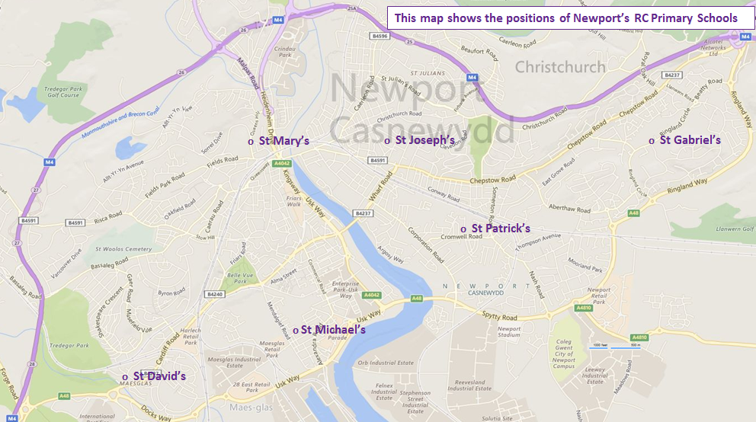 | St Gabriel’s RC Primary School  Ringland Circle, Newport NP19 9PQ  Tel no: 01633 273937  Email : stgabriels.primary@newportschools.wales  Website: www.stgabrielsrcprimary.org.uk

If you have a question contact your first choice school, who will be happy to help

Welcome letter
Dear Parents,

As Roman Catholic schools we are very proud of our Catholic tradition and the Gospel Values upon which our faith is built.

The aim of Catholic Schools in Newport is to create a stimulating, secure, happy and caring environment of which you and your children will become an integral part. We very much want to develop a partnership between home, school and Parish as it is through working together in an atmosphere of mutual respect and support that we can provide what is best for our children, in order that they may be happy, enriched and fulfil their potential.

This information booklet explains the process, requirements and responsibility of parents to ensure the enclosed application form is completed, along with the correct documentation, and returned to your first preference Catholic school in Newport.

What you need to do:
- Use a single form to apply to up to three Newport RC Primary schools
- List the schools to which you are applying in order of preference
- Submit the form to your highest preference RC school
  - Your highest preference RC school will share details of your application with any lower preference RC schools
- Wherever possible you will be offered a place at your first choice school
  - If this school is full you will, where possible, be offered a place at another RC Primary School taking your preferences into account
- If you wish also to apply for a place at a Community or Voluntary Controlled school you must do this separately using the Newport City Council process see website: www.newport.gov.uk/schooladmissions
Timetable
Admissions forms available  13th November 2025 | Closing date for applications  15th January 2026 | Offer Date  16th April 2026

Checklist for applicants:

- Do you have parental responsibility for the child for whom the application is being made? If no, please ask the person with parental responsibility to complete and sign the application form. If you have parental responsibility but are not the parent, have you provided the relevant evidence as detailed under Section I of the guidance notes?

- If the child for whom the application is being made is under the care of a local authority, has the Social Worker signed the application?

- Have you provided all the documentation required e.g. proof of address, baptismal certificate etc.?
Please provide photocopies as the School cannot guarantee the safe return of original documents and is unable to provide a photocopying service.

- Have you answered all questions fully and to the best of your knowledge, including details of siblings and any relevant medical factors?

- Have you signed the application form?

- Will your application be received by your first choice RC Primary School before the closing date?

Admission Arrangements
The Governing Body of each school is the Admissions Authority and is responsible for determining and administering the policy relating to the admission of pupils to the school. It is guided in that responsibility by the requirements of the law, by the advice of the Diocesan trustees and its duty to the school and the Catholic Community. Each Governing Body has delegated responsibility for determining admissions to its “Admissions Committee”
A copy of the policy is available from your RC primary school.
Admission Numbers September 2026
The Admission Number is the capacity of the year group (i.e. the numbers of pupils per year group) at the school and is set by Newport Local authority, using a formula set by the Welsh Government
St David’s 30 | St Gabriel’s 30 | St Joseph’s 30
St Mary’s 60 | St Michael’s 30 | St Patrick’s 30

Guidance notes for completing the Application Form
Section A:
School preferences: You must use a single form to apply to up to three Newport RC Primary schools. Please list the schools in order of preference. The form must be submitted to your highest preference RC school they will share details of your application with any lower preference RC schools. Expressing a preference will give your child priority over children whose parents have not expressed a preference for that school.
If you wish also to apply for a place at a Community or Voluntary Controlled primary school, you must do so using the Newport City Council process.
Section B:
Child’s full legal name: The legal name is the name stated on the birth certificate (unless you have legally changed the child’s name since birth. In this case please provide a copy of the legal change of name papers). The School will refer to your child by their legal name for the purposes of this application.
Child’s home address: The School may undertake residency checks and reserves the right to request independent confirmation of the child’s address. Applicants may be asked to supply additional documentation to support their application. e.g. Child Benefit or Tax Credit
Baptism: If your child is Roman Catholic you must provide a copy of the Baptismal Certificate.
Section C:
Parent / Guardian details: The application must be made by an adult who has parental responsibility for the child. Where parental responsibility is shared, the School will ask the child’s parents to determine which parent should submit the application. If parents cannot agree and neither has obtained a court order stating who should be making the application, the School will accept an application from the parent in receipt of Child Benefit for the named child.
Where the child is in the care of a local authority the Social Worker must sign the application form.
Section D:
Nursery: Attending a Nursery class does not guarantee a place at any primary or infant school as a separate application is required and priority is not given to those children attending any specific nursery setting.
Special Educational Needs (SEN): Children with a formal statement of SEN are afforded priority only if the school to which the parent is applying is named in the Local Authority’s Statement.
Section E:
Medical circumstances: Where the preference is based on the child’s medical grounds, the application must be supported by a medical consultant’s report, obtained by the parents, specifying the medical advantage of the child attending the preferred school. Reports from family doctors are not accepted for this purpose.
Section F:
Siblings: Children who will have a brother or sister at the school to which the parent is applying on the date of admission will be given higher priority than those who do not. However, having a sibling at the school does not guarantee admission. Priority will be given to children closest in age to the sibling already attending the preferred school. Brothers and sisters, whether half, full, step, or foster will be considered where living in the same household.
Section G:
Proof of residency: A current Council tax bill is preferred. Alternatively, you may provide a current child benefit / child tax credit notification naming the child for whom the application is being made.
Proof of date of birth: A copy of the child’s birth certificate is preferred. Alternatively, you may provide a copy of an NHS medical card or valid passport.
Proof of Baptism: If your child is Roman Catholic you must provide a copy of the Baptismal Certificate.
Fraudulent claims will be investigated and places will be withdrawn if applicants have provided false information.
Section H:
Declaration: Please make sure that you have signed the declaration. Where parental responsibility is held by someone other than the child’s mother or father you must submit evidence of this with the application. Acceptable evidence would be a copy of a legal document awarding parental responsibility.

Oversubscription Criteria for Admission to a Newport Roman Catholic Primary School 2026-2027

The Governing Body of each R.C. Primary School is the Admissions authority.
Where the number of applications is equal to or less than the number of places available, all applications will be successful. However, where the number of applications exceeds the number of places available, the Governing Body will apply the following oversubscription criteria to all applications and allocate places accordingly.

Where a Newport R.C. Primary School is named in a statement of Special Educational Needs, the Admissions Authority has a duty to admit the child to the school before the over-subscription criteria is applied against applications received.

The criterion will be applied in rank order.

- Baptised Roman Catholic Looked After Children (LAC- children in the public care) or previously Looked After Children.
- Baptised Roman Catholic children who have siblings in the school at the time of admission.
- Baptised Roman Catholic children.

Confirmation of Baptism will be required in each of the above categories.

- Looked After Children (LAC- children in the public care) or previously Looked After Children of other Christian or Non-Christian faiths.
- Children of other Christian denominations who have a sibling in the school at the time of admission.
- Children of other Christian denominations whose parents have demonstrated a wish for a Catholic education. Each application should be supported by a letter or evidence of practice of worship from their religious leader.
- Children of other faith traditions who have a sibling in the school at the time of admission.
- Children of other faith traditions whose parents have demonstrated a wish for a Catholic education. Each application should be supported by a letter or evidence of practice of worship from their religious leader.
- Other children with a sibling in the school at the time of admission whose parents demonstrate a wish for Catholic education.
- Other children whose parents demonstrate a wish for Catholic education.

After considering the above categories, or if the number of applications in any one category exceeds the published admission number, priority will be based on those residing closest to the preferred school with the exception of St David’s where the priority will be based on those who live furthest from an alternative school (i.e. a Roman Catholic Voluntary Aided School with a place available when the child is to be admitted).
Notes:
(i) An application without the correct evidence is not complete. The processing of incomplete applications may be delayed and this could affect the timing of the decision. Applications must be supported by a photocopy of the child’s birth certificate, NHS medical card or valid passport to authenticate the child’s date of birth in all cases

The Admissions Authority also requires proof of residency in support of all applications, and for this purpose parents/carers must submit a copy of their current year’s Council Tax Statement in order to verify their home address. Any applicant unable to provide this, should submit other photocopied evidence in order to verify the home address. This must be a valid driving licence, a current child benefit or tax credit notification.

(ii) The Governing Body will consider the child’s home address to be the place where the child permanently resides for the majority of the school week, as at the stipulated closing date for applications. This would normally be at the same address as the person who has parental responsibility for the child and is the main carer. Where the child spends equal time with both parents/carers, the place of residence of the person who receives the child benefit will be considered the child’s home. Evidence may be required to support this.

(iii) Where it is possible to admit some, but not all of the children who fall within one particular category within the Oversubscription Criteria, preference will be given to those children whose homes are within the shortest walking distance to the main entrance of the school as measured using the Local Authority’s own specific Geographical Information Systems (GIS) routing software, Routefinder and MapInfo Desktop Solutions (with the exception of St David’s where the priority will be based on those who live furthest from an alternative school (i.e. a Roman Catholic Voluntary Aided School with a place available when the child is to be admitted). In order to ensure fairness and consistency for all applicants, this is the only measurement tool that is used by the schools.

(iv) Siblings are: brothers and sisters, whether half, full, step, adopted or fostered will be considered relevant where living in the same household and where an older child will still be registered at the school when the younger child will be eligible to attend. Where there is more than one such case, priority will be given to those children closest in age to the siblings already attending the school, as at the admission date.

(v) Multiple Births: If when applying the oversubscription criteria, the last child to be admitted is one of a multiple birth the governors will admit the other sibling(s).

Late applications
Any applications received after the closing date, or applications that remain incomplete as at the closing date will only be processed after places have been allocated for applications that were received by the closing date, and this may increase the possibility of not achieving a place at the school.
Any such applications received after the published closing date will be processed on a monthly basis and decision letters issued by the end of the calendar month following receipt.

